How to Include New Species on the Master Data Sheet for Previous Years

Master data sheet

* All_West_Beach_Data, All_North_Beach_Data, All_Fifth_Beach_Data, All_Maey_Channel_Data

1. Copy and paste the percent cover data for each tide height from year’s data sheet.

Each quadrat is represented by a column and species within that quadrat are rows. Headers for rows are in the following format.

Data is added to the sheet “LOW, MID or HIGH”

SITE_TIDE_YEAR_QUADRAT#

Eg FB_HIGH_2017_1

* + 10 new quadrats are added per year

1. In order to add new species, add a row to the entirety of the data sheet. Then fill the previous years with zeroes

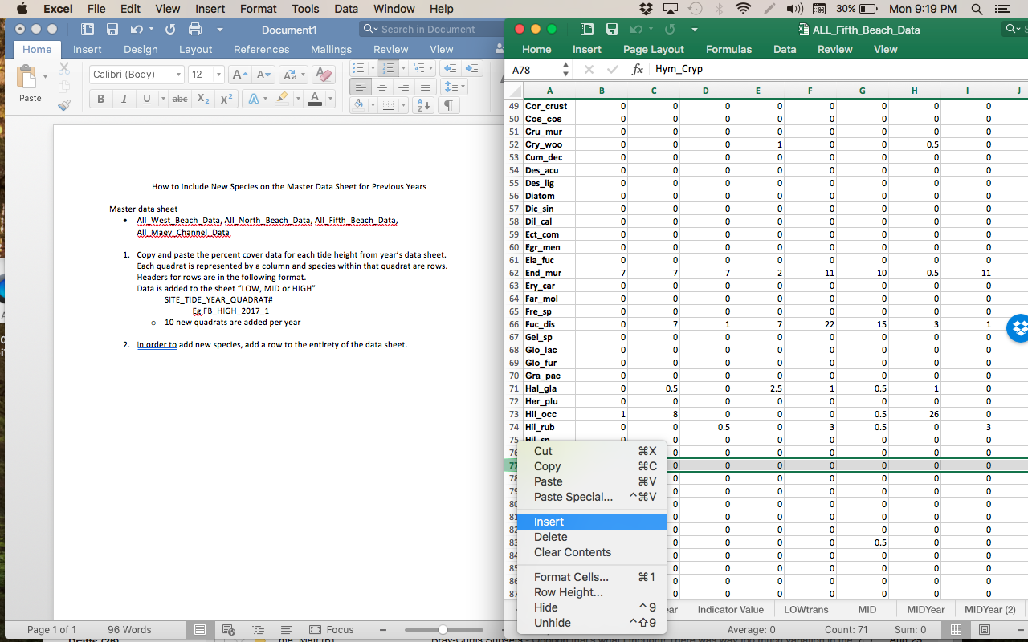

1. In order to format data for R, copy all data to a new sheet and when pasting, select “Paste Special” and select “transpose”. The rows which were species will now be columns. Format is seen in the sheet marked “LOWtrans, ect”
2. If needed, add variables by inserting columns. Format is seen in the sheet marked “LOWYear, ect”